Fitness Plan
NAME: _______________________________________________ PERIOD _______ GRADE _______

Statement of Inquiry: Choices can affect the development of our health and well-being.

MYP OBJECTIVES
A. Knowing and Understanding
- Recalls physical and health education factual, procedural and conceptual knowledge that relates to health and well-being.
- Applies physical and health terminology to communicate understanding with limited success.
B: Planning for Performance
- Design and explain a plan for improving our physical health and well-being.
C: Applying and Performing
- Demonstrate and apply a range of skills and techniques to improve health outcomes
- Demonstrate and apply a range of fitness movement concepts
D: Reflecting and Improving Performance
- Explains and evaluates performance

Answer each Inquiry question in complete sentences:

- How do choices affect the development of health and well-being? ________________________
______________________________________________________________________________

- How does the environment around me affect my eating habits?__________________________
______________________________________________________________________________

- How does the environment around me affect the way I work out/exercise?_________________
______________________________________________________________________________

- Are there any possible obstacles that will affect me reaching my fitness goal? _______________
______________________________________________________________________________

Define the Five Components of Fitness

Body Composition: _____________________________________________________________________
Flexibility: ____________________________________________________________________________
Muscular Strength: _____________________________________________________________________
_____________________________________________________________________________________
Muscular Endurance: ___________________________________________________________________
_____________________________________________________________________________________
Cardiorespiratory Endurance: ____________________________________________________________
_____________________________________________________________________________________

Weight ___________ Height ___________ BMI ___________ AGE ___________
Fitnessgram Test Standards and Record Sheet

Test | PRETEST SCORE | POST SCORE | HEALTHY ZONE | RESULTS: OK/NI/HP
MILE
PACER
BMI
CURL-UP
PUSH-UP
RIGHT SHOULDER
LEFT SHOULDER
*NI: NEEDS IMPROVEMENT OK: IN THE HEALTHY FITNESS ZONE HP: HIGH PERFORMANCE (exceeds limit)

Boys Healthy Zone Charts
AGE | Mile | PACER | CURL-UP | PUSH-UP | TRUNK LIFT
11 | 8:30—11:00 | 23-72 | 15-28 | 8-20 | 9-12
12 | 8:00-10:30 | 32-72 | 18-36 | 10-20 | 9-12
13 | 7:30-10:00 | 41-83 | 21-40 | 12-25 | 9-12
14 | 7:00-9:30 | 41-83 | 24-45 | 14-30 | 9-12
15 | 7:00-9:00 | 51-94 | 24-47 | 16-35 | 9-12

Girls Healthy Zone Charts
AGE | Mile | PACER | CURL-UP | PUSH-UP | TRUNK LIFT
11 | 9:00-12:00 | 15-41 | 15-29 | 7-15 | 9-12
12 | 9:00-12:00 | 15-41 | 18-32 | 7-15 | 9-12
13 | 9:00-11:30 | 23-51 | 18-32 | 7-15 | 9-12
14 | 8:30-11:00 | 23-51 | 18-32 | 7-15 | 9-12
15 | 8:00-10;30 | 32-51 | 18-35 | 7-15 | 9-12

How many areas can you improve in, if any? _________________________________________________
_____________________________________________________________________________________

Which fitnessgram test do you plan to improve? _____________________________________________

Which health related component(s) of fitness is represented by this exercise?

_____________________________________________________________________________________

Follow these guidelines to setting SMART goals and The F.I.T.T. Principle to create your plan:
- Specific. Your goal should be clear and easy to understand.
  - A common goal, “get healthy,” is too general. There are so many ways to get healthy. Is it losing weight? Increasing curl ups or pacers? Fitnessgram can be a baseline for what you need to improve.
- Measurable. A goal to “lose weight” is not enough. How will you track your progress and how you will know when you have reached your goal? Making your goal measurable means adding a number. How will you measure your intensity?
- Attainable. Before you can add a number, you must know how high or low you want to go. It’s good to ‘shoot for the stars’, but don’t be too extreme. Only you know your limits.
  - A measurable, attainable goal could be, “I will lose 1-2 pounds a week.”
- Relevant. Set goals that are important to where you are in your life right now. Don’t set a goal that someone else is pressuring you to attain-that isn’t very motivating. Does it seem relevant to you?
- Time-bound. Include an end-point. Knowing that you have a deadline motivates you to get started.
1: What is your SMART fitness goal: _______________________________________________
____________________________________________________________________________
2: Which Component of Fitness will you focus on? ____________________________________

____________________________________________________________________________

3: What muscles will you focus on? ________________________________________________

******Examples

- Example: I plan to improve my pacer test by 10 pacers. My fitness goal is to lose 10-15 pounds in one month.

- I will improve my cardiorespiratory endurance and body composition.

- Muscles: quadriceps, hamstrings, gluteus and calves, obliques, abdominals, biceps, and triceps, leading to increased overall strength and endurance.

Define the F.I.T.T. Principle

Frequency: ___________________________________________________________________________
Intensity: _____________________________________________________________________________
Time: ________________________________________________________________________________
Type: ________________________________________________________________________________

One month fitness plan will include which fitnessgram test that you plan to improve.
Fill in How Frequent will you plan to work out for the month.
Intensity, Time, and Type will be filled out within the calendar for each day.
The plan is for you to improve your fitnessgram scores when you complete the post test.

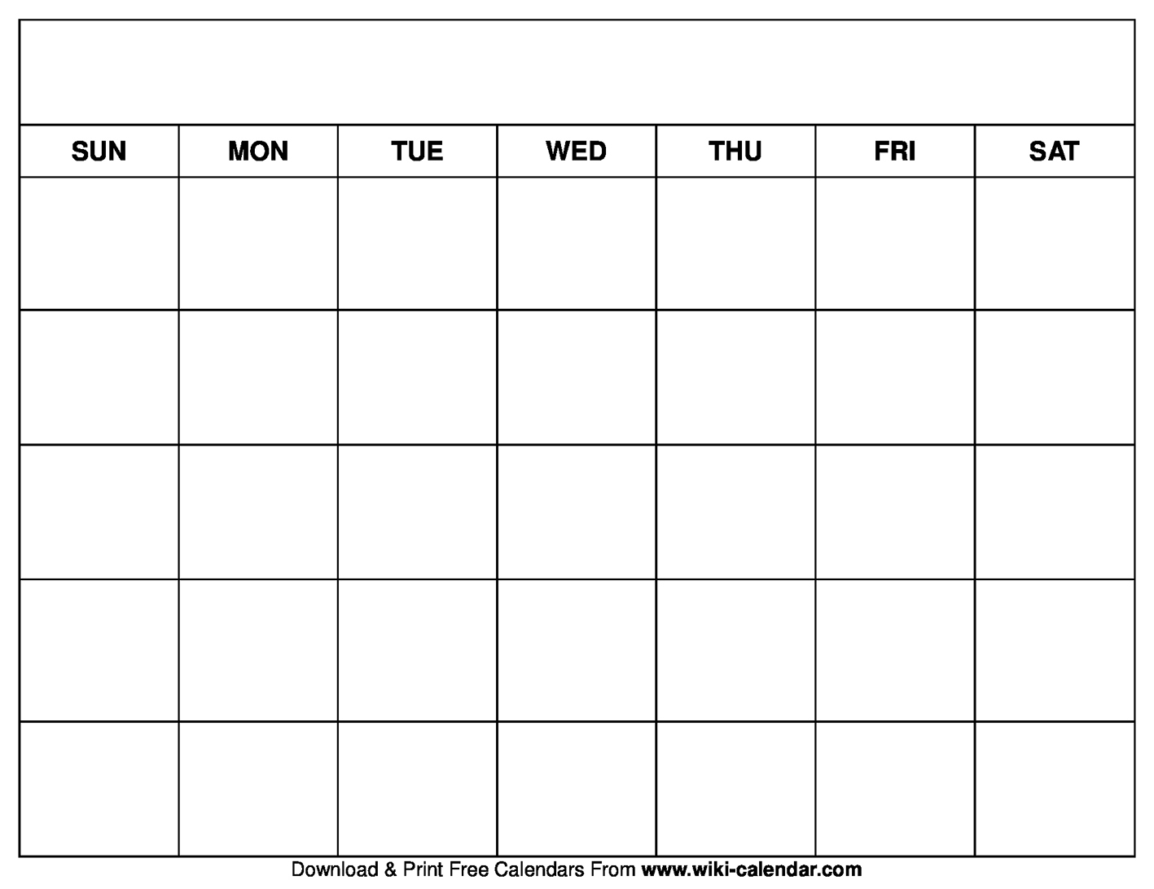

Reflection
- What went well? ____________________________________________________________________
- What adjustments would you make to your plan for next time? ______________________________________________________________________________________
- Were there any obstacles that slowed down your progress? What were they?
______________________________________________________________________________________

